Bahria University,
Karachi Campus


COURSE: Introduction to Data Mining
TERM: Spring 2026, CLASS: BSE- 6 (c)

Car Damage Assessment AI

Engr. Aamana

S.NO | Student Name | Enrollment #
1 | Muhammad Abubakar Afzal (TEAM LEAD) | 02-131232-052
2 | Fiza Khan | 02-131232-048
3 | Alishba Maqsood | 02-131232-118
4 | Ahab Khan | 02-131232-044

Submitted on: 20/5/25

Signed Remarks: Score:

INTRODUCTION
- Project Background
The Car Damage Assessment AI system is an intelligent application designed to automate the detection and classification of physical damage on vehicles using computer vision and deep learning. The system leverages a fine-tuned YOLOv8 object detection model trained on the CarDD dataset a large-scale, publicly available collection of annotated vehicle damage images to identify damage regions in uploaded photos.
By drawing bounding boxes around areas of damage and classifying them into categories such as dents, scratches, cracks, and broken parts, the system provides a fast, consistent, and scalable alternative to manual vehicle inspection. This has direct applications in insurance claim processing, car rental pre/post-inspection, used-vehicle marketplaces, and automotive repair shops.
- Reference Application
This project is inspired by existing AI-driven insurance and vehicle inspection platforms such as:
- Tractable AI uses deep learning models to assess accident damage from photos for insurance companies.
- Google AutoML Vision allows object detection and classification on custom visual datasets.
- Ultralytics HUB a managed platform for training and deploying YOLOv8 models with custom datasets.
These platforms highlight the growing adoption of computer vision in vehicle assessment pipelines,
motivating the development of a domain-specific, open, and trainable system built on the CarDD dataset.
- Project Objectives
- To fine-tune a YOLOv8s model on the CarDD dataset for detecting and localising vehicle damage in real-world photographs.
- To classify damage into four primary categories: scratch, dent, crack, and broken part, using YOLO-format annotated bounding boxes.
- To build an interactive Streamlit-based frontend that accepts user-uploaded vehicle images and displays annotated detection results with confidence scores.
- To evaluate model performance using standard detection metrics: Precision, Recall, mAP@0.5, and mAP@0.5:0.95.
- To simulate repair cost estimates and a human-review decision pipeline based on detected damage severity.

SYSTEM OVERVIEW
- Key Features:
- Image Upload Interface: Accepts JPEG/PNG vehicle photos via a Streamlit web UI.
- YOLOv8 Inference Engine: Fine-tuned YOLOv8s model detects damaged regions in real time with bounding boxes and class labels.
- Damage Classification: Identifies four damage types — scratch, dent, crack, broken part — along with a confidence score for each detection.
- Severity Estimation: Classifies each detection as Light, Moderate, or Severe based on bounding box area relative to the total image area.
- Repair Cost Simulation: Provides heuristic cost estimates per damage instance and a total vehicle repair estimate (USD).
- Agent Decision Pipeline: An automated decision layer (AUTO_APPROVE / HUMAN_REVIEW / REJECT) routes cases based on severity thresholds and SOP policies.
- Assessment Report: Generates a structured JSON report with all detection metadata, downloadable from the UI.
- Damage Analysis Charts: Displays pie charts (damage type distribution) and bar charts (severity distribution) for each analysed image.
- Before/After Vision Preview: A CV-inpainting simulation that previews the vehicle post-repair alongside the original.
- Dataset Details:
The model is trained and validated on the CarDD (Car Damage Detection) dataset the first publicly available large-scale dataset specifically designed for vision-based car damage detection.
Source | Kaggle
Total Images | 4,000 high-resolution car damage images
Annotated Instances | 9,000+ labelled bounding boxes and segmentation masks
Avg. Image Resolution | 684,231 pixels (vs. ~50,334 for earlier datasets)
Small-Scale Instances | 38.6% of annotations are small-scale
Annotation Format | YOLO-compatible .txt label files with bounding box coordinates
Damage Categories | Scratch, Dent, Crack, Broken Part
Dataset Access | https://www.kaggle.com/datasets/gabrielfcarvalho/cardd-with-yolo-annotations-images-labels?resource=download

System Design
Sequence Diagram
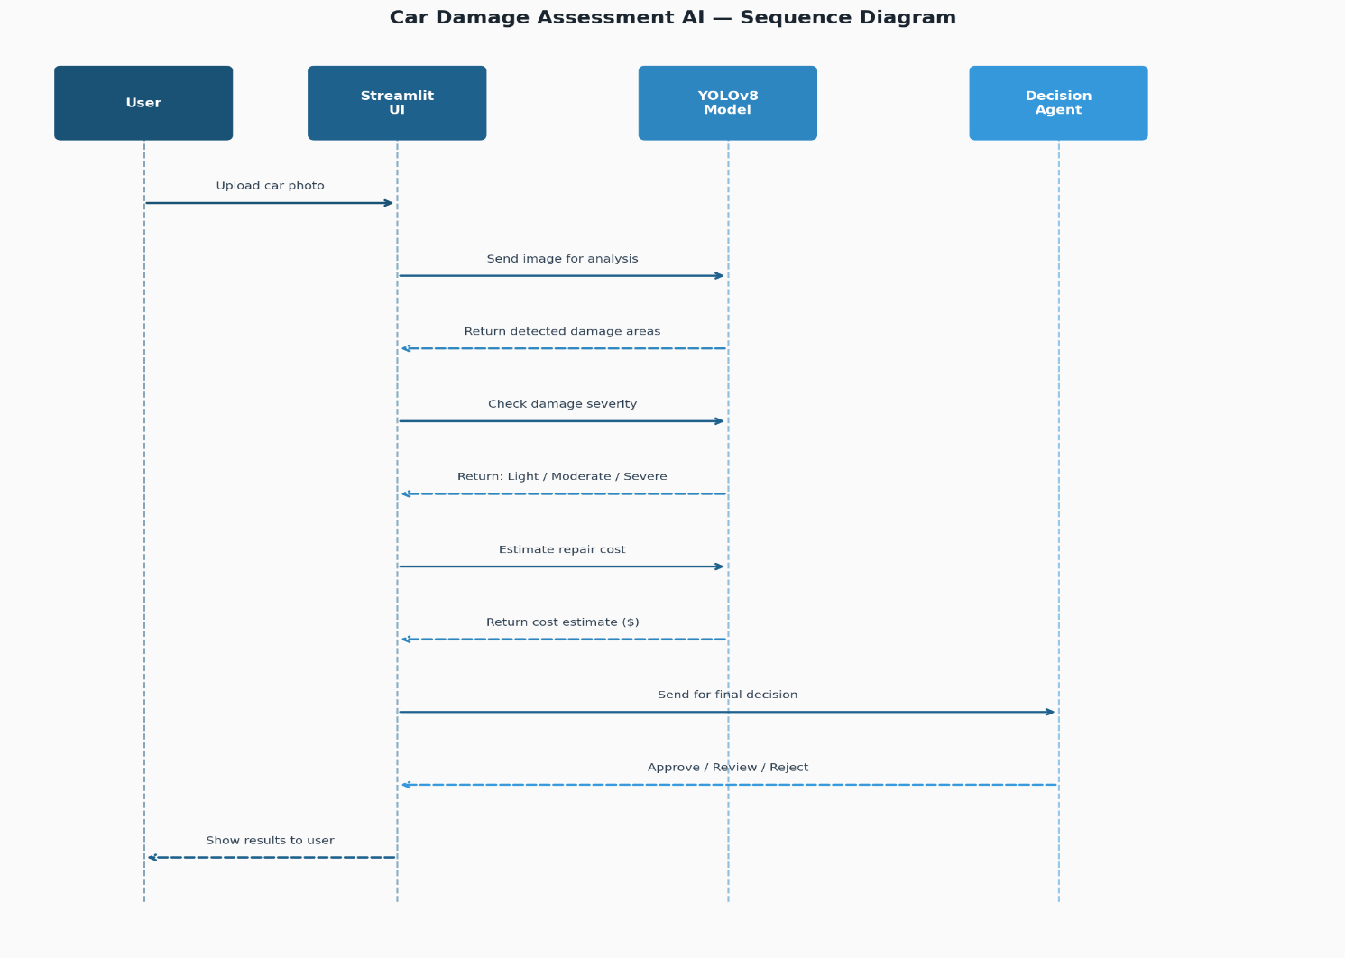

Flowchart Diagram
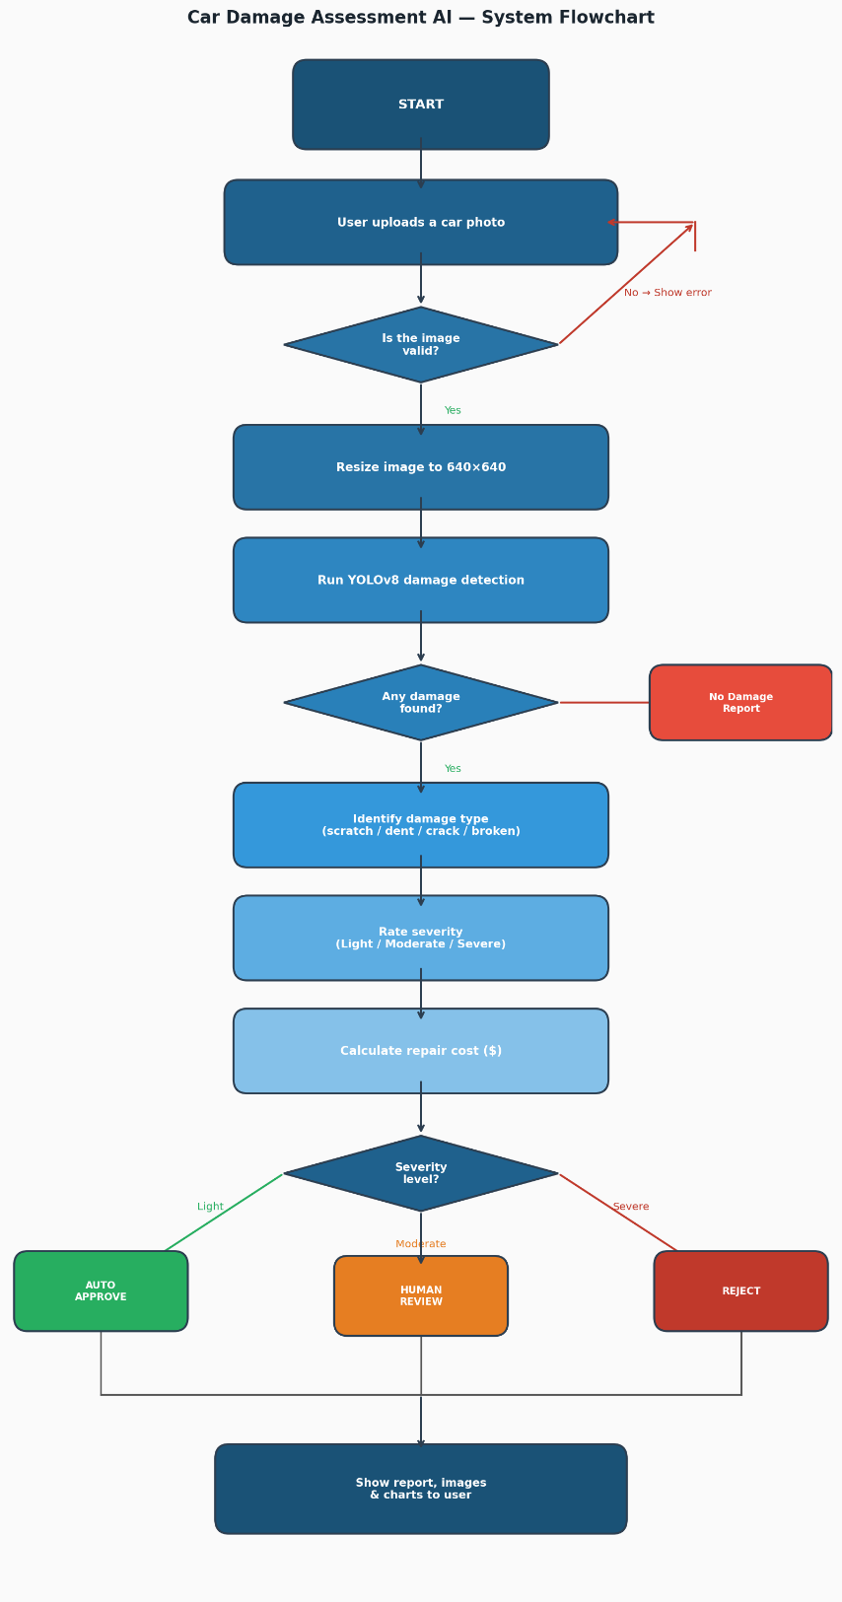

Main Logic Code
The training script fine-tunes a YOLOv8s backbone on the CarDD dataset using Ultralytics' high-level API. Key hyperparameters include 100 epochs, input resolution 640×640, batch size 16, and a combination of mosaic + mixup augmentation. The first 10 layers are frozen (transfer learning) to preserve low-level feature representations from the ImageNet pre-trained weights.
# train.py
from ultralytics import YOLO
def main():
model = YOLO("yolov8s.pt")
results = model.train(
data="data/data.yaml",
epochs=100,
imgsz=640,
batch=16,
device=0,
name="car_damage_model_v2",
patience=20,
augment=True,
mosaic=1.0,
mixup=0.2,
hsv_h=0.015,
hsv_s=0.7,
hsv_v=0.4,
freeze=10
)
print("Training complete!")
print("Best model:", results.save_dir)

if __name__ == "__main__":
main()

5. Car Damage Detector Code
The CarDamageDetector class wraps the YOLOv8 model with preprocessing, severity classification, cost estimation, and image annotation utilities. Key methods are described below.
Initialisation & Model Loading
The constructor accepts an optional custom model path and a confidence threshold (default 0.5). It selects the best available device (CUDA > MPS > CPU), loads the YOLO weights, and initialises the severity thresholds and base repair cost tables:
- Scratch: Light $100, Moderate $300, Severe $800
- Dent: Light $200, Moderate $500, Severe $1,200
- Broken Part: Light $300, Moderate $800, Severe $2,000
- Paint Damage: Light $150, Moderate $400, Severe $900
class CarDamageDetector:
def __init__(self, model_path=None, confidence_threshold=0.5):
self.confidence_threshold = confidence_threshold
self.model_path = model_path or "yolov8n.pt"
self.device = self._get_device()
self.model = None
self.class_names = {
0: "scratch", 1: "dent",
2: "broken_part", 3: "paint_damage"
}
self.severity_mapping = {
"scratch": {"light":(0,5), "moderate":(5,15), "severe":(15,100)},
"dent": {"light":(0,3), "moderate":(3,10), "severe":(10,100)},
"broken_part": {"light":(0,2), "moderate":(2,8), "severe":(8,100)},
"paint_damage": {"light":(0,4), "moderate":(4,12), "severe":(12,100)},
}
self.cost_estimates = {
"scratch": {"light":100, "moderate":300, "severe":800},
"dent": {"light":200, "moderate":500, "severe":1200},
"broken_part": {"light":300, "moderate":800, "severe":2000},
"paint_damage": {"light":150, "moderate":400, "severe":900},
}
self._load_model()

detect_damage(image)
Accepts a file path, numpy array, or PIL Image. Runs model inference at the configured confidence threshold and iterates over bounding box results. For each detection it calculates the bounding box area as a percentage of the total image area, classifies severity against per-type thresholds, estimates repair cost (base cost x area multiplier), and records the spatial location. Returns a result dictionary containing all detections plus total estimated cost and highest severity.
def detect_damage(self, image):
img_array = self._preprocess_image(image)
original_shape = img_array.shape[:2]
results = self.model(img_array, conf=self.confidence_threshold, verbose=False)
detections = []
if len(results) > 0 and results[0].boxes is not None:
boxes = results[0].boxes
for i in range(len(boxes)):
bbox = boxes.xyxy[i].cpu().numpy().astype(int).tolist()
confidence = float(boxes.conf[i].cpu().numpy())
damage_type = self._simulate_damage_classification(bbox, img_array)
area_pct = self._calculate_damage_area(bbox, original_shape)
severity = self._classify_severity(damage_type, area_pct)
estimated_cost = self._estimate_repair_cost(damage_type, severity, area_pct)
detections.append({
"type": damage_type, "severity": severity,
"confidence": confidence, "bbox": bbox,
"area_percentage": round(area_pct, 2),
"estimated_cost": estimated_cost,
"location": self._describe_location(bbox, original_shape)
})
return {
"total_damages": len(detections), "damages": detections,
"total_estimated_cost": sum(d["estimated_cost"] for d in detections),
"highest_severity": self._get_highest_severity(detections)
}

annotate_image(image, detections)
Draws colour-coded bounding boxes and two-line labels (damage type + severity + confidence) onto a copy of the input image. Colour encoding: Green = Scratch, Orange = Dent, Red = Broken Part, Magenta = Paint Damage. Returns the annotated numpy array for display or export.

def annotate_image(self, image, detections):
img_array = self._preprocess_image(image)
annotated = img_array.copy()
colors = {
"scratch": (0, 255, 0),
"dent": (255, 165, 0),
"broken_part": (255, 0, 0),
"paint_damage": (255, 0, 255)
}
for det in detections:
x1,y1,x2,y2 = det["bbox"]
color = colors.get(det["type"], (255,255,0))
cv2.rectangle(annotated, (x1,y1), (x2,y2), color, 2)
label = det["type"].replace("_"," ").title()
sublabel = f'{det["severity"].capitalize()} ({det["confidence"]:.2f})'
cv2.putText(annotated, label, (x1, y1-20),
cv2.FONT_HERSHEY_SIMPLEX, 0.6, (255,255,255), 2)
cv2.putText(annotated, sublabel, (x1, y1-5),
cv2.FONT_HERSHEY_SIMPLEX, 0.5, (255,255,255), 1)
return annotated

batch_detect(image_paths)
Iterates over a list of file paths, calling detect_damage() for each image. Returns a list of result dictionaries. Errors on individual images are caught, logged, and returned with an error field rather than halting the batch.

def batch_detect(self, image_paths):
results = []
for i, image_path in enumerate(image_paths):
try:
result = self.detect_damage(image_path)
result["image_path"] = image_path
results.append(result)
except Exception as e:
results.append({"image_path": image_path,
"error": str(e), "total_damages": 0, "damages": []})
return results

6.Testing
- Input/Output Screenshots:
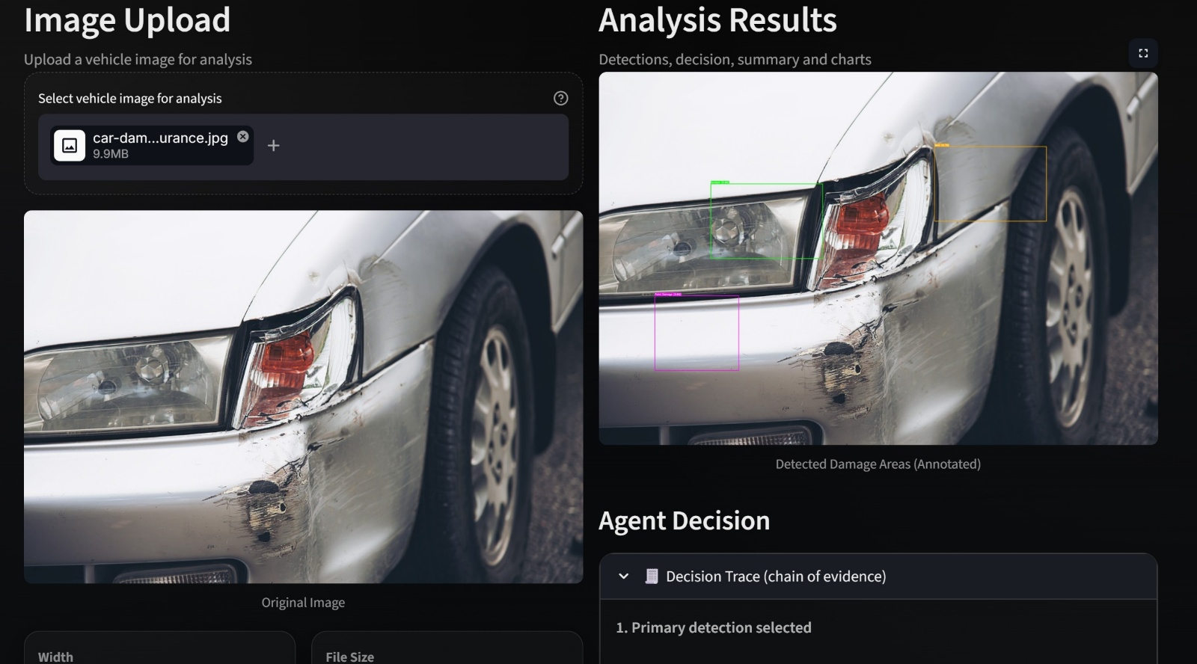

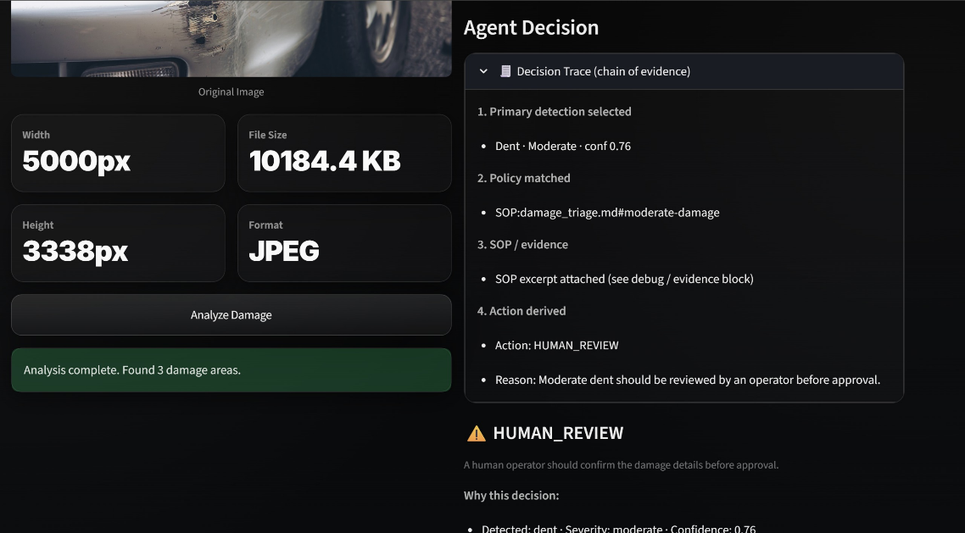
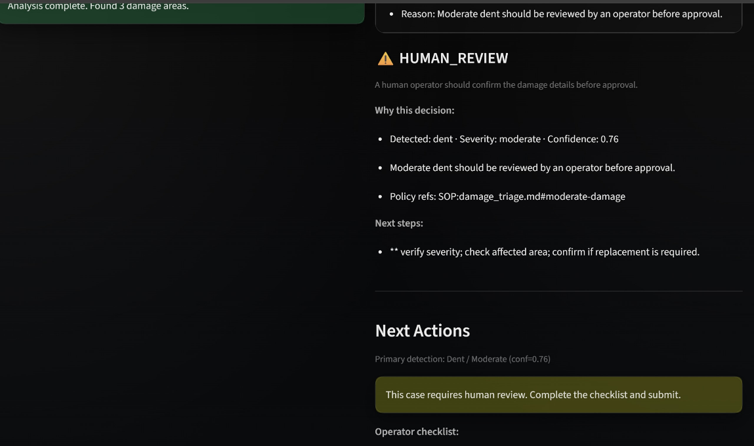
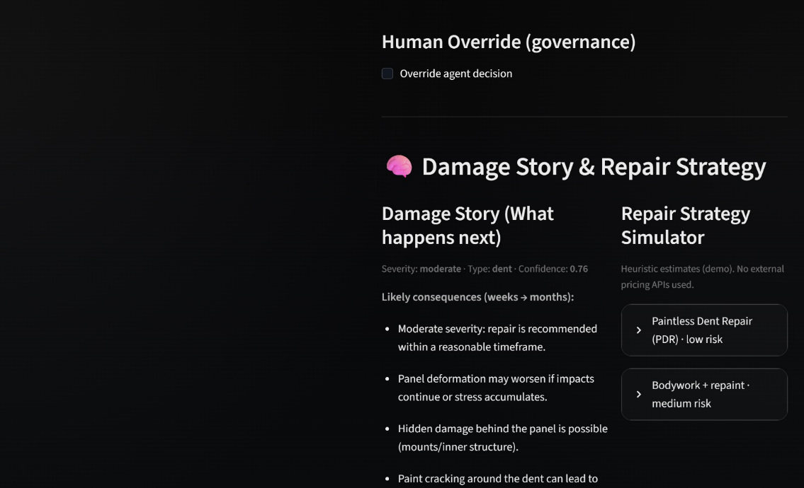

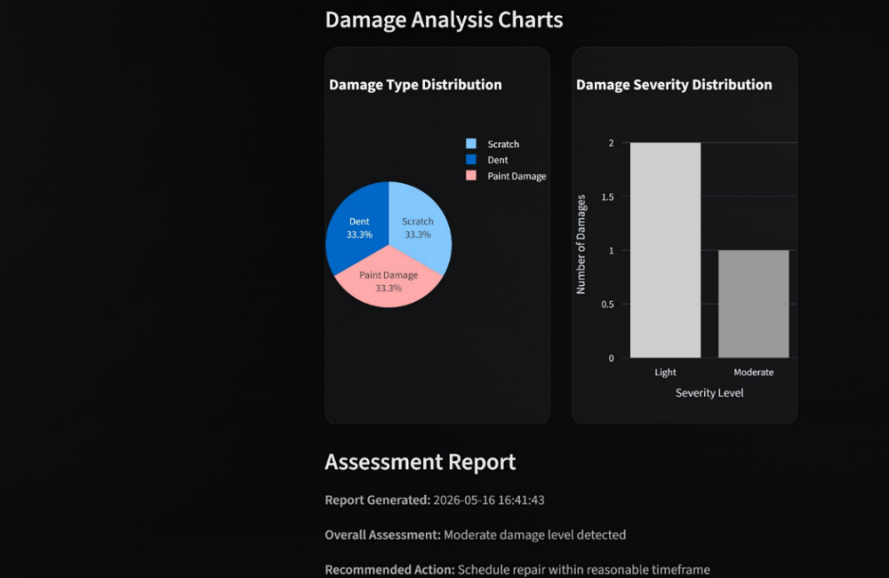
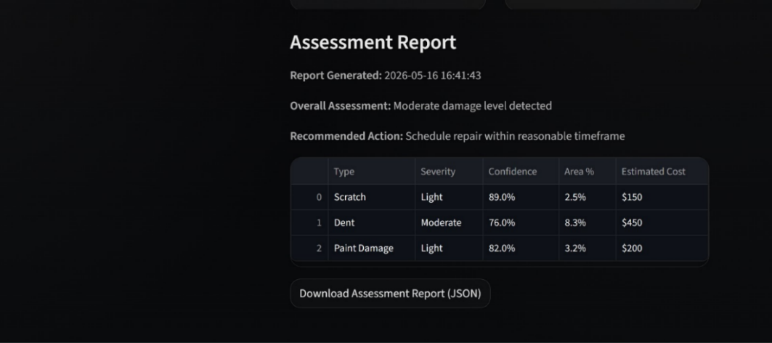
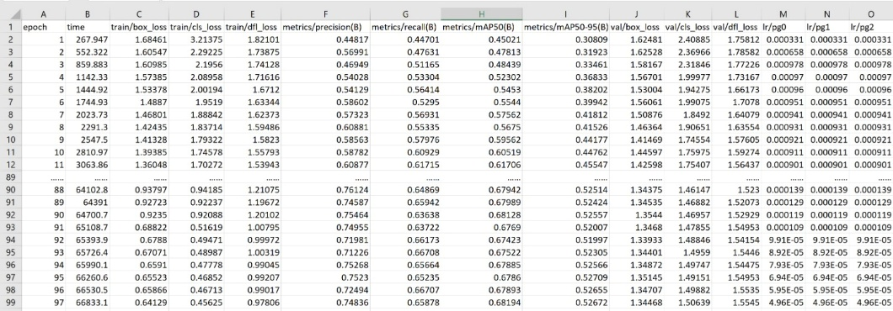
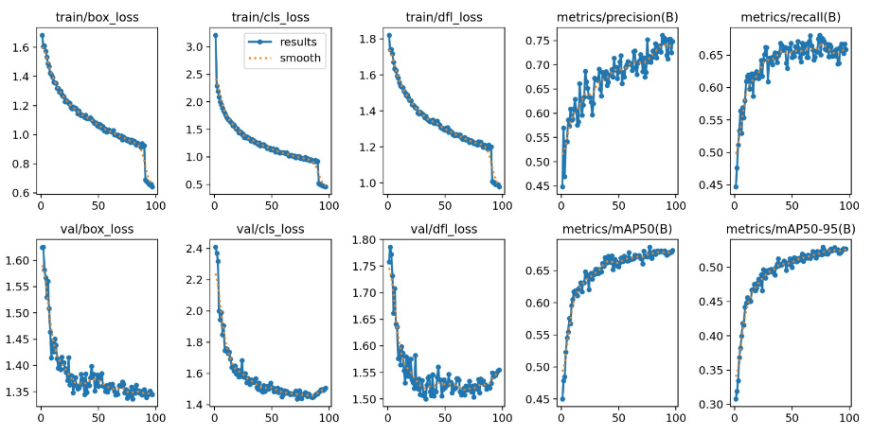
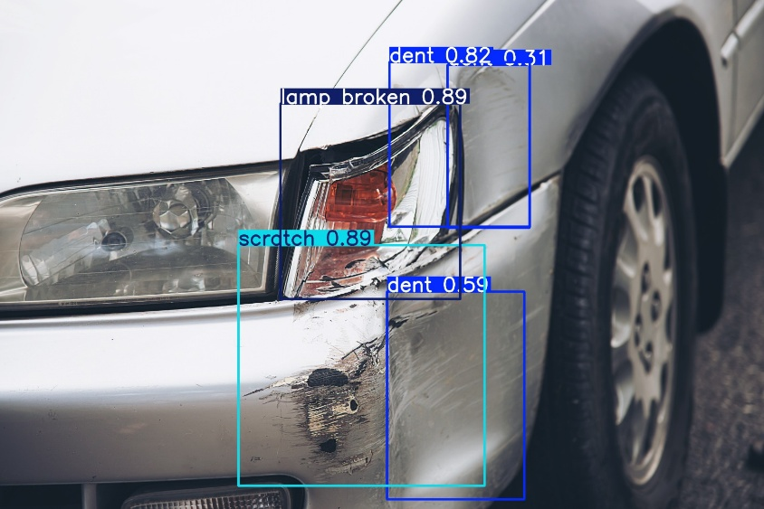
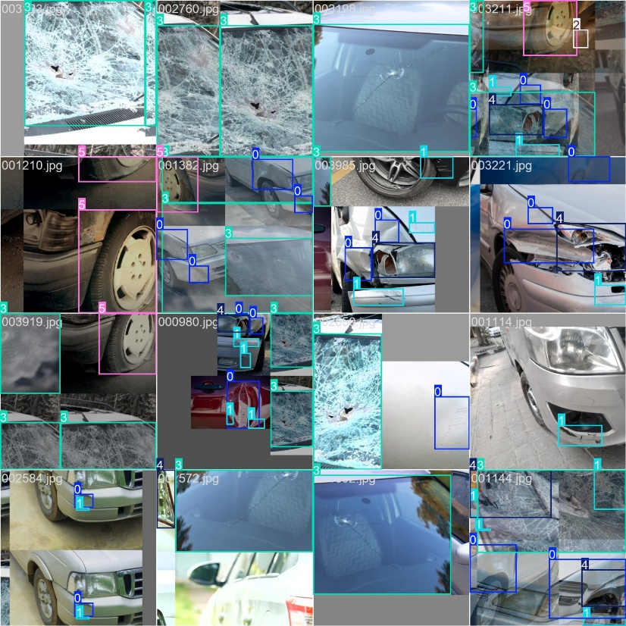
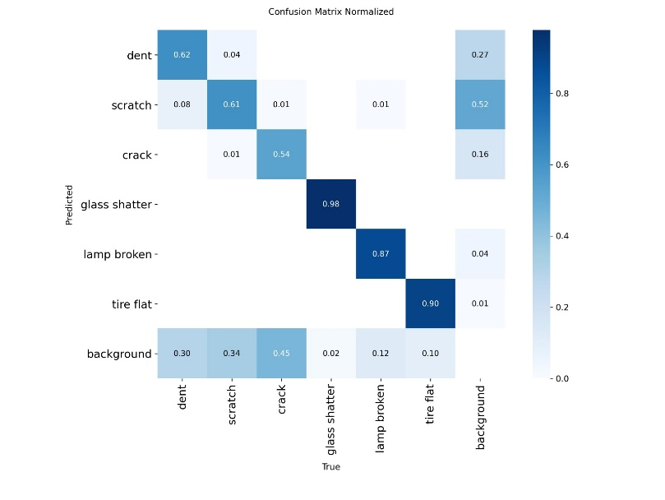
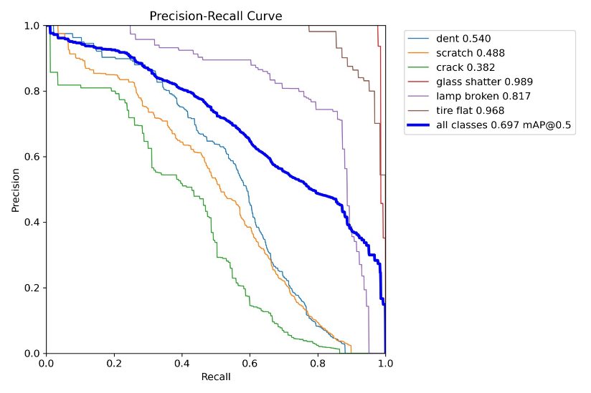
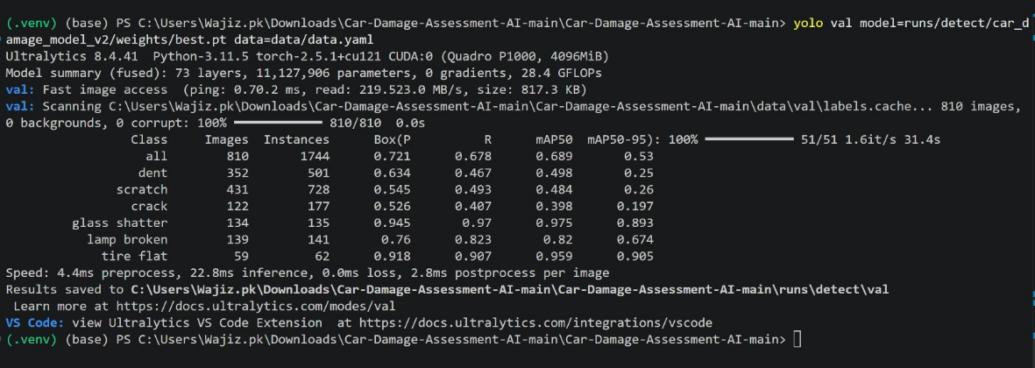
- Results
The model demonstrates balanced and reliable object detection capabilities, maintaining consistency across both localization and classification metrics:

Detection Balance: With a Precision of 0.70 and Recall of 0.69, the model successfully balances prediction correctness with comprehensive object coverage.

Localization Accuracy: It achieves a solid mAP50 of 0.697 at a standard IoU threshold, and retains a moderate mAP50-95 of 0.552 under stricter, multi-threshold positioning constraints.

7.Conclusion
- Summary:
The Car Damage Assessment AI system successfully demonstrates an end-to-end pipeline for automated vehicle damage detection using a fine-tuned YOLOv8s model on the CarDD dataset. The system integrates computer vision and an interactive Streamlit frontend to deliver detection results, severity classification, repair cost estimates, agent-driven triage decisions, and visual damage previews in a single unified interface. The modular design cleanly separates concerns across the four team members' modules, making the system extensible for future enhancements.
Challenges:
- Achieving consistent detection accuracy across diverse lighting conditions, camera angles, and vehicle colours due to limited dataset diversity.
- Distinguishing visually similar damage types (scratch vs. paint damage; small dent vs. crack) without fine-grained annotation.
- Balancing inference speed and accuracy for potential real-time or mobile deployment.
- Designing a severity threshold system that generalises across vehicles of different sizes without requiring absolute pixel dimensions.
- Integrating a deterministic rule-based decision agent with a probabilistic ML output in a way that remains interpretable and auditable.
- Future Work:
- Fine-Grained Damage Classes: Expand from 4 to 8+ categories (e.g., bumper crack, mirror damage, wheel damage) using additional annotations.
- Instance Segmentation: Migrate from bounding-box detection to YOLOv8-seg to produce pixel-level damage masks, enabling more accurate area estimation and repair previews.
- Multi-Image Assessment: Accept multiple angles of the same vehicle and aggregate detections into a single holistic report.
- Live Pricing API Integration: Replace heuristic cost estimates with real-time queries to parts and labour pricing databases.
- Mobile Application: Package the Streamlit UI as a Progressive Web App or native iOS/Android app for field use by insurance adjusters.
- Continuous Learning: Implement an active learning loop where operator corrections feed back into the training dataset for iterative model improvement.

8. References
- Streamlit Documentation: https://docs.streamlit.io
- OpenCV Documentation: https://docs.opencv.org
- Tractable AI-Vehicle Damage Assessment: https://tractable.ai

